#Retuns !5

#returns !6

#retuns !0

#!1.2 #factorials for none integers doe not exist

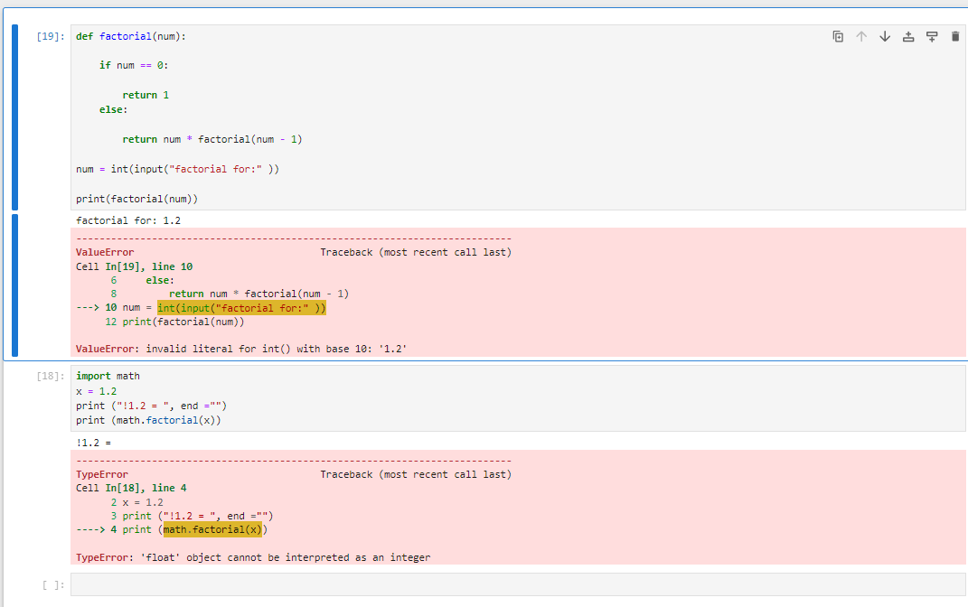

#!Spam

#!-2 no factorials for negative numbers

